**Corda : Distributed Ledger Technology**

* Used by businesses, such as financial institutions
* Keep a shared ledger of transactions
* No need to know about each and every transactions
* A Corda network is made up of nodes running Corda and CorDapps
* Communication between nodes is point-to-point, no global broadcasts.
* The network is permissioned, with access controlled by a doorman

**Corda Network : Detailed Overview**

A Corda Network includes

1. Doorman -: Provide access to eligible nodes with a root-authority-signed TLS certificate.
2. Network Map Service -: Publishes IP addresses through which all nodes can be reached
3. Corda Nodes (2 or more) -: Regular nodes communicate with other nodes, notaries & oracle
4. Notary Nodes (1 or more) -: Attest uniqueness and validity of ledger updates.
5. Oracle Services (0 or more)-: Link ledger to outside world.

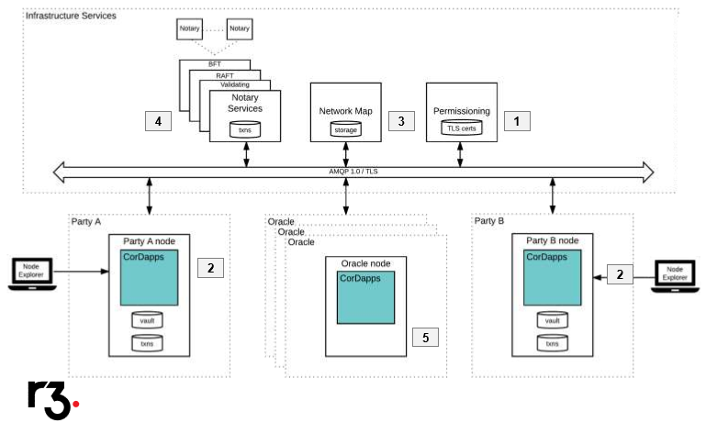

**Corda Setup (Windows)**

Note -: Use Java JDK version 8 (jdk-8u131-windows-x64)

<https://docs.corda.net/tutorial-cordapp.html#downloading-the-example-cordapp>

* Open Gitbash and clone corda tutorial

git clone https://github.com/corda/cordapp-tutorial

* Open project in Intellij IDEA and run the project (Run Example Cordapp-Kotlin)
* In Gitbash go to the root of tutorial CordApp and run below command

./gradlew.bat deployNodes

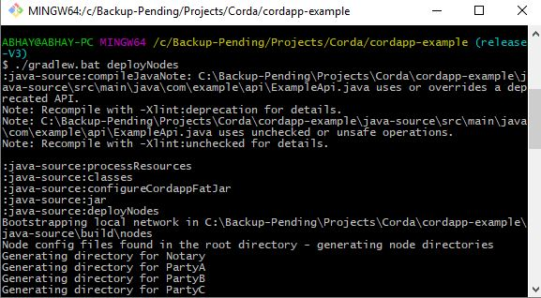

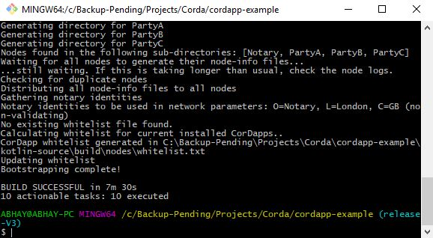

* Once the nodes are deployed run them by executing below command.

Kotlin-source/build/nodes/runnodes

C:\Backup-Pending\Projects\Corda\Stuffs\RunNodes.JPG

* Above command will start 8 terminal windows (4 nodes + 4 web servers)
* Test that nodes are running correctly by opening a browser and navigating to URL as shown below.

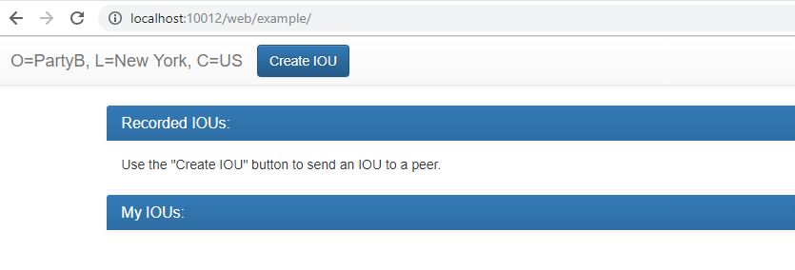

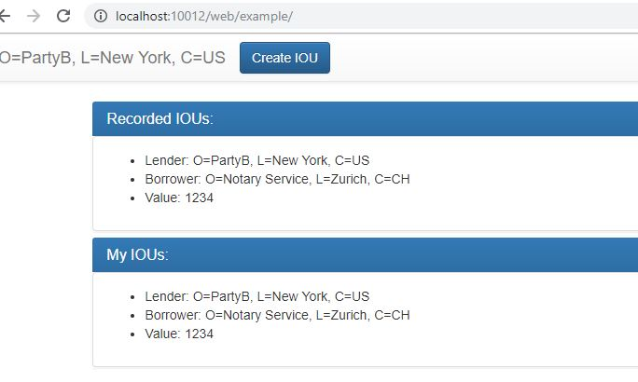

**Possible Errors**

Proxy error

Go to Intellij IDEA (File -> Settings) and set the proxy as shown below

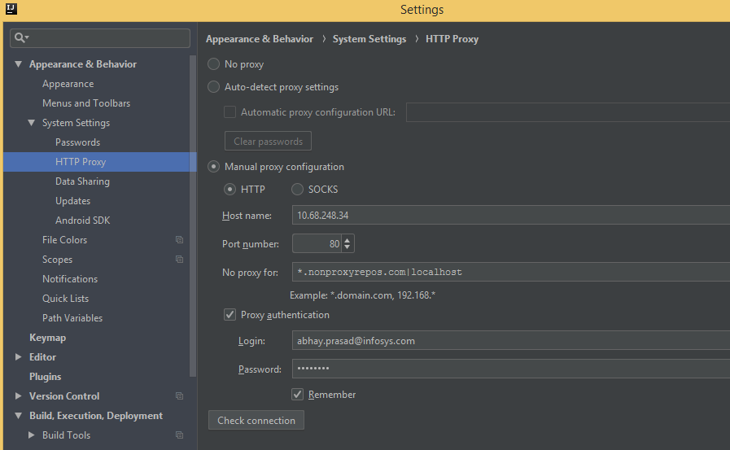

Automatic library version update for Gradle projects is currently unsupported. Please update your build.gradle manually

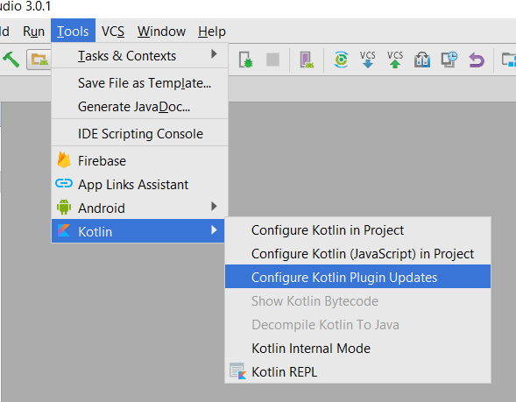

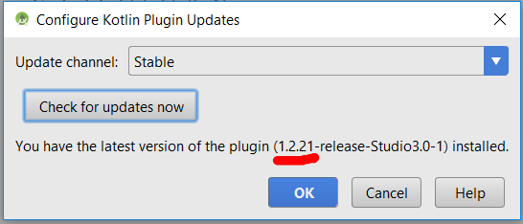

kotlin unresolved reference core as shown below

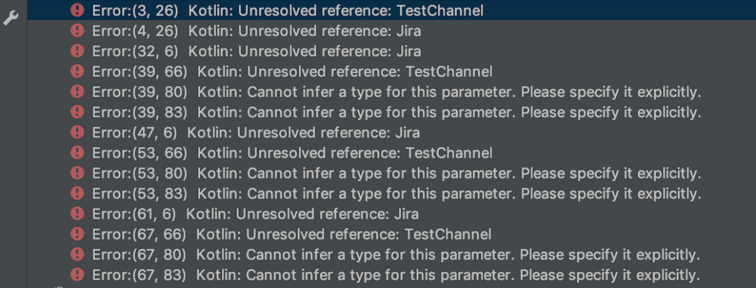

Make sure Kotlin compiler Target JVM version is set correctly as shown below

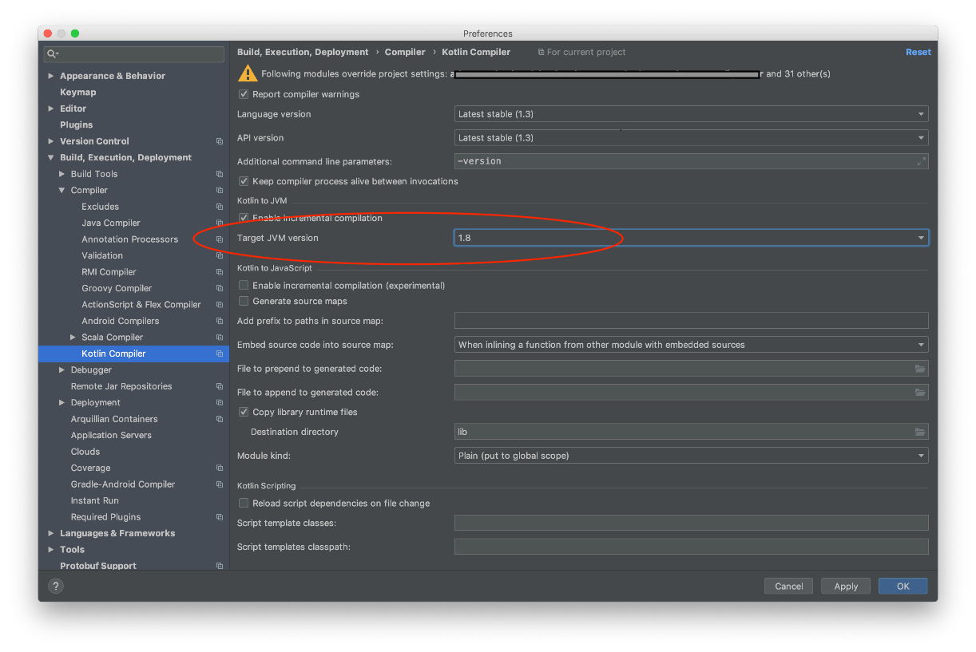

And Java Compiler project bytecode version is 8

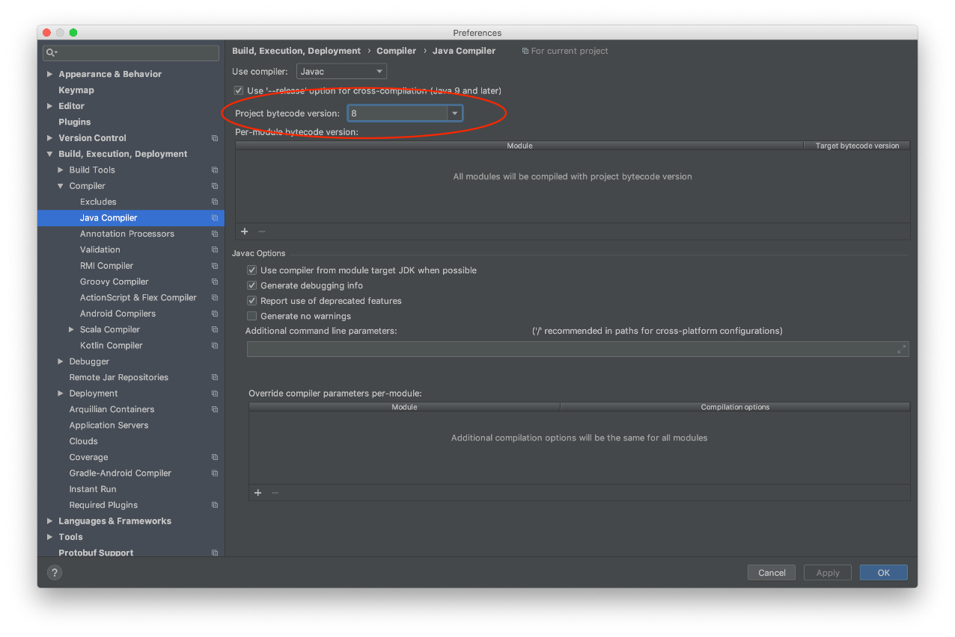

Project

<https://medium.com/corda/developing-with-corda-cb28093b7c1a>